**HR Analytics - Boosting Retention with Data Insights at Adecco India**

**Background:**

Adecco India, a tech company, is facing high employee turnover, especially among junior sales employees. This turnover is costly and affects productivity.

**Problem Statement:**

**Problem:** High turnover among junior sales employees is disrupting team dynamics and increasing costs.

**Importance:** Reducing attrition will lower costs, improve productivity, and foster a stable workforce.

**Solution:**

**Data Analysis:**

1.    **Customer Behavior Analysis:**

o   Understand customer usage patterns and preferences.

o   Identify trends and areas for improvement.

2.    **Service Quality Improvement:**

o   Reduce customer complaints.

o   Enhance overall customer experience.

3.    **Pricing Strategies:**

o   Offer competitive pricing and special deals.

o   Attract and retain customers.

4.    **Communication Enhancement:**

o   Strengthen communication channels for clear interactions with customers.

**Data-Driven Insights:**

1.    **Pattern Identification:**

o   Uncover common reasons for churn.

2.    **Predictive Analysis:**

o   Forecast and mitigate at-risk customers.

3.    **Customer Segmentation:**

o   Develop targeted retention strategies for different customer groups.

**Stakeholder Engagement:**

1.    **Internal Stakeholders:**

o   HR, Sales, Engineering, Marketing, Customer Support, Senior Management.

2.    **External Stakeholders:**

o   Recruitment Agencies, Training Providers.

**Project Scope:**

1.    **Customer Behavior:**

o   Analyze usage patterns and preferences.

2.    **Service Quality:**

o   Improve to reduce complaints.

3.    **Pricing:**

o   Offer competitive deals.

4.    **Communication:**

o   Strengthen interaction channels.

**Methodology:**

1.    **Data Sources:**

o   HRIS, Performance Management System, Employee Surveys, Exit Interviews.

2.    **Data Wrangling:**

o   Review, format, and enhance data.

3.    **Exploratory Data Analysis (EDA):**

o   Identify trends and patterns.

4.    **Data Visualization:**

o   Use Excel for charts and graphs.

**Goals & KPIs:**

1.    **Goals:**

o   Increase new customer acquisition.

o   Improve retention rate.

o   Reduce churn rate.

o   Increase market share.

2.    **KPIs:**

o   New Customer Acquisition.

o   Customer Retention Rate.

o   Churn Rate.

**Recommended Analysis:**

1. **What is the overall attrition rate at Adecco India?**

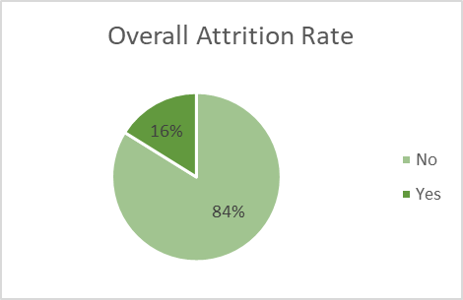

**2. Which department has the highest attrition rate?**

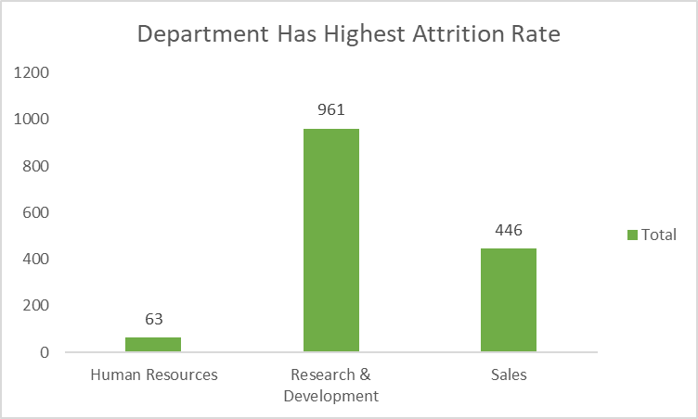

**3. What is the average age of employees who have left the company?**

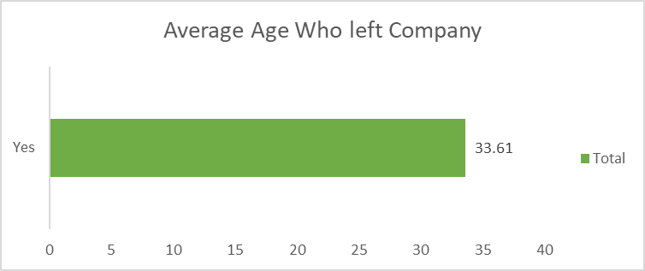

**4. How does job satisfaction vary across different job roles?**

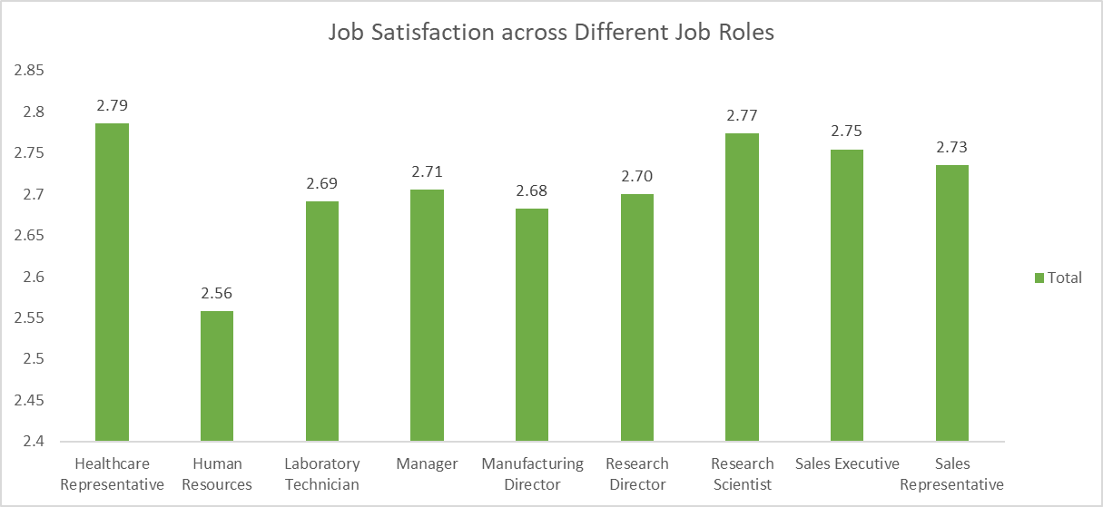

**5.Is there a significant difference in attrition rates between male and female employees?**

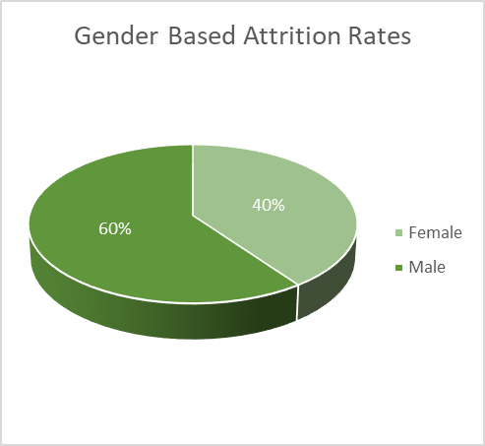

**6 : What is the average monthly income of employees who have left the company?**

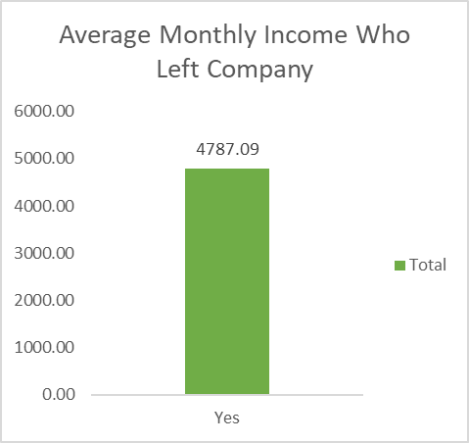

**7. How does distance from home impact employee attrition?**

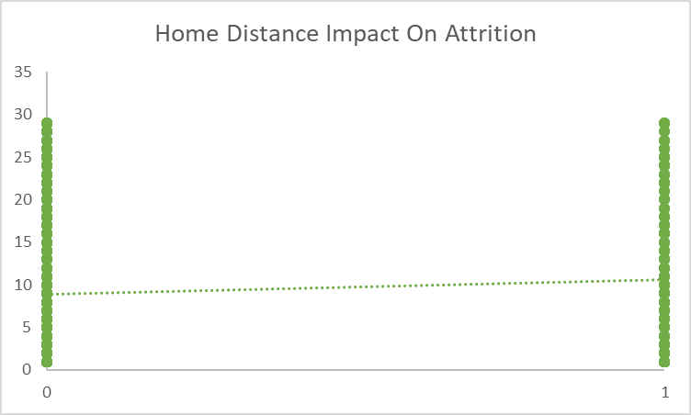

**8. What is the distribution of performance ratings among employees?**

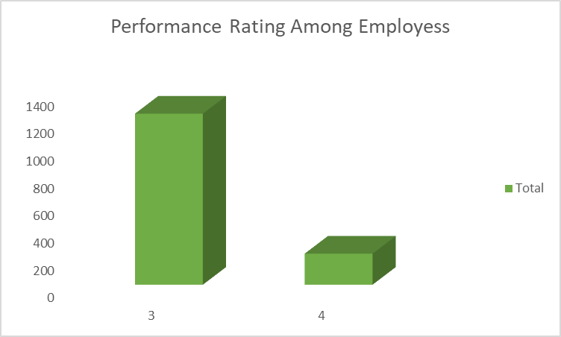

**Dashboard**

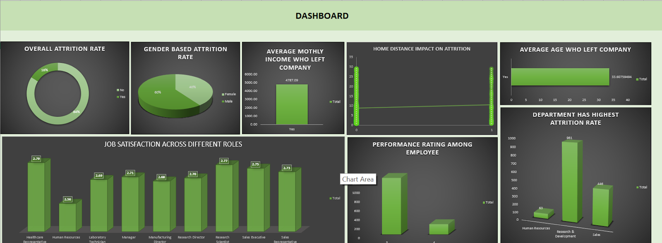

**Conclusion:**

**Turnover Causes**: High turnover was mainly due to job dissatisfaction, long commutes, and lower performance ratings.

**Sales Department Impact**: The Sales Department had the highest attrition rates, significantly impacting overall turnover.

**Demographic Trends**: Younger employees and those in junior roles were more likely to leave, highlighting the need for role-specific improvements.

**Commute and Income Effects**: Longer commutes and lower monthly incomes were significantly correlated with higher attrition.

**Project owner**

Name:Devanshi Thakkar

Date: 2 June , 2024